MINUTES OF THE ANNUAL GENERAL MEETING OF THE MOTORHOME CLUB OF SOUTH AFRICA
HELD AT KAIA MANZI BRONKHORTSPRUIT ON SATURDAY, THE 22nd of October 2022

- Welcome

The Chairman extended a warm welcome to all present and in particular to the Regional Chairman, 5 Regions were present.

- ATTENDANCE
- Attendance as per register
- Proxies
9 (nine) proxies were received.
- Apologies received:
Johan Marais (Garrun)
Koos & Ria Strydom
Ron & Bryony Downs
Pieter & Riana Diddloff
Mada de Lange & Leon Hefer
Phillip & Mariki van der Walt
Robert Jackson
Ross & Brenda McSweeney
Lampies Lambrecht

- ESTABLISHMENT OF A QUORUM AND OPENING OF MEETING
After confirming that due notice of the meeting had been given and that the quorum of a minimum of 10 members in good standing were present, the Chairman declared the meeting open.

- APPROVAL OF THE MINUTES ON THE ANNUAL GENERAL MEETING HELD AT GARIEP 30.10.2021
These minutes were published in the 4th issue of the Motorhomer in 2021. No amendments were required and were accepted as an accurate recording of the meeting.

Approved: Johan Theart Seconded: Ari Korver

- MATTERS ARISING FROM PREVIOUS MINUTES
Nil

- CHAIRMANS REPORT
Welcome to all our Motorhoming Family, our last AGM was at Gariep a year ago and what a fantastic event that turned out to be. It is great to see that we have representation from five of our seven regions at the AGM, a big achievement considering the distance needed to travel to get here - Well Done!!! The club has since held highly successful Northern and Southern regional convergence rallies in March of 2022 and will again hold these two events in 2023. We then come to the big one, our 40th Anniversary of the club in 2024 when our next National Convergence will be held – really looking forward to that.
Four of our Regions have new Chairperson’s congratulations to Lampies Lambrecht of Garden Route, Athna de Jager of Western Cape, Ben de Lange of Free state, and Karel Leimecke.
I would like to thank Okkie Duvenage for all the years of looking after our Web Site and welcome Sandy Morton as our new Web Manager. I ask all our regions to please keep Sandy updated on upcoming rallies so she can keep the web up to date. Sandy also runs a camping site web site, Gallivanting SA, highly informative and updated. There is a link from our web site to Gallivanting SA – check it out. Please let us know what you think of our new web site.
The financial position of the club Nationally and Regionally is strong, most of the funds collected nationally are distributed as Capitation and funding of regional convergences. The club growth seems to hit a resistance line around 800 members, we surpass this during the year, we topped 830 this year only to lose significant numbers again at financial year end.
The question has been asked “What about midweek rallies “in addition to normal weekend rallies – reason being much better rates during the week, price of fuel and distance to travel. I support this initiative, there is nothing restricting rallies, it must be sanctioned by the regional committees, maybe run by a midweek subcommittee or person, advertised and open to all.
Thank you to Nowell for our Facebook page, we have 10000 members currently, quite an achievement! Then to Maryna the Editor of our magazine for an excellent job – the magazine is very well done!
To the National Committee thank you for all the support and hard work put in during my term in office. To the incoming National Committee, I wish you the very best and support you wholeheartedly. Finally thank you to my wife Val for your support, proof reading and having to listen to my nonsense.

Happy Motorhoming – we will see you on the road.
Tim Swanepoel

- TRESURERS REPORT (Presented by Marius Kruger)
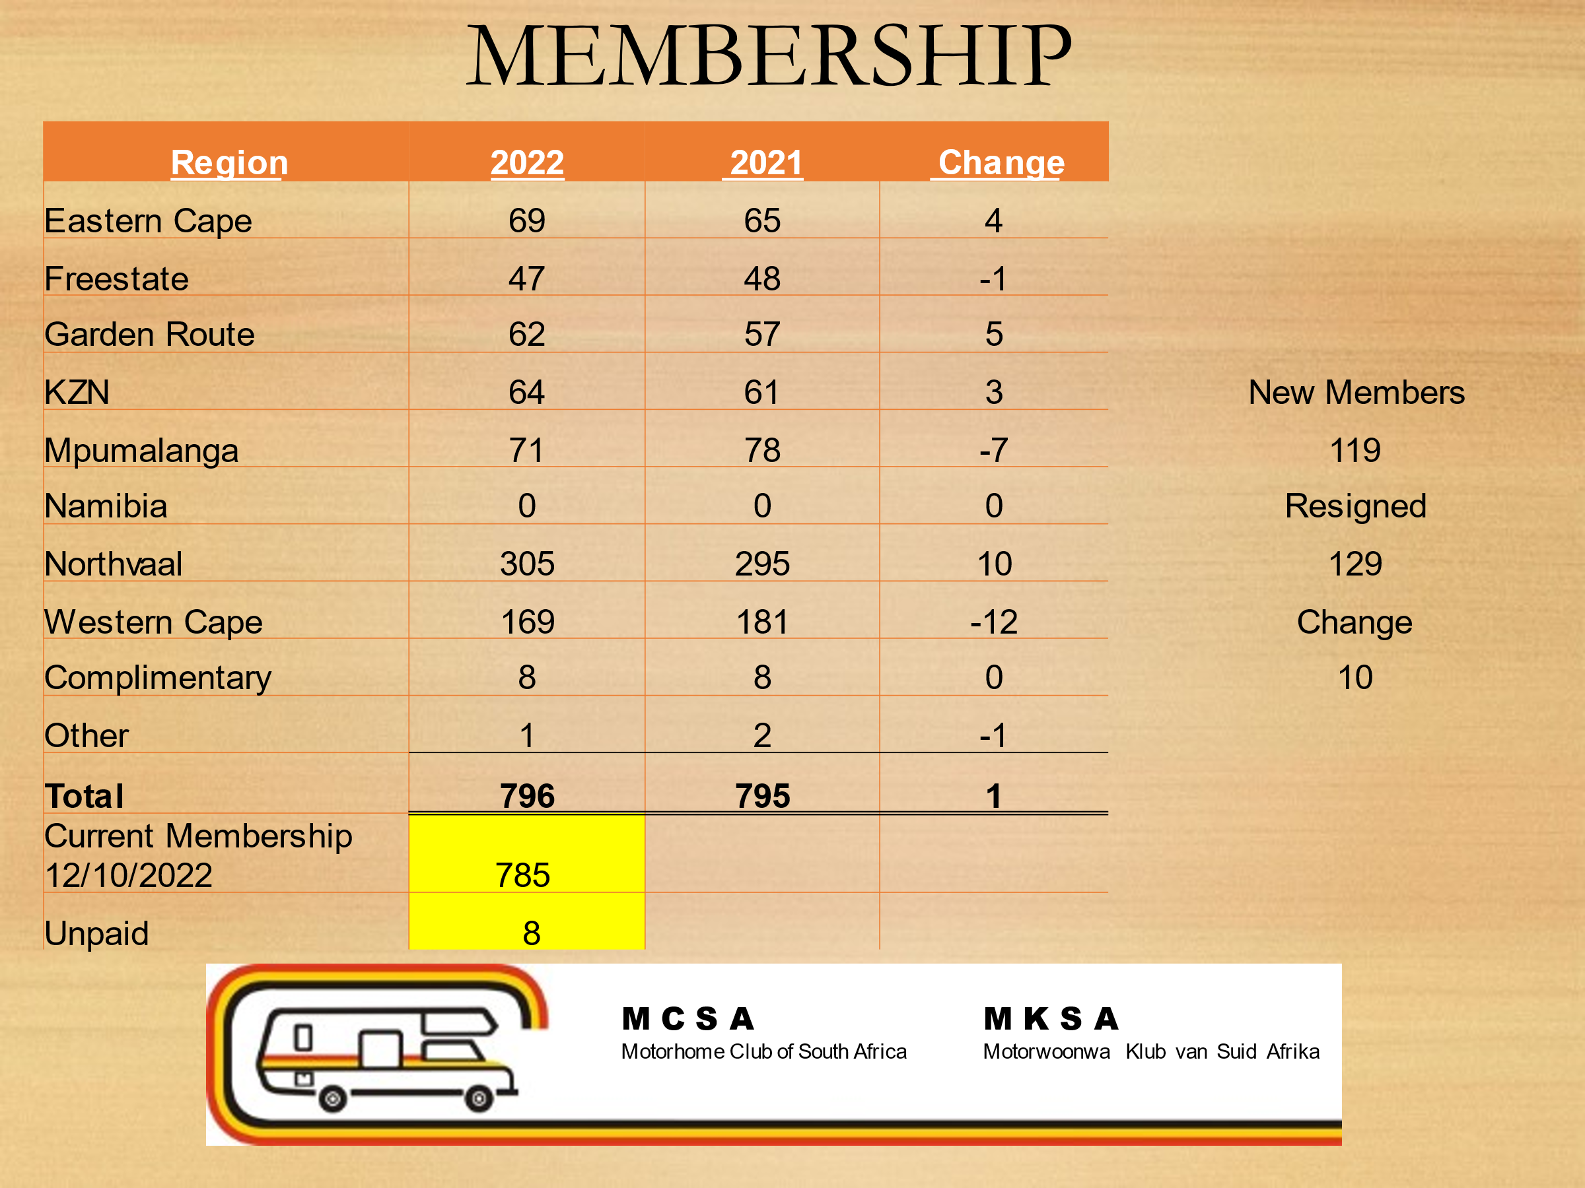

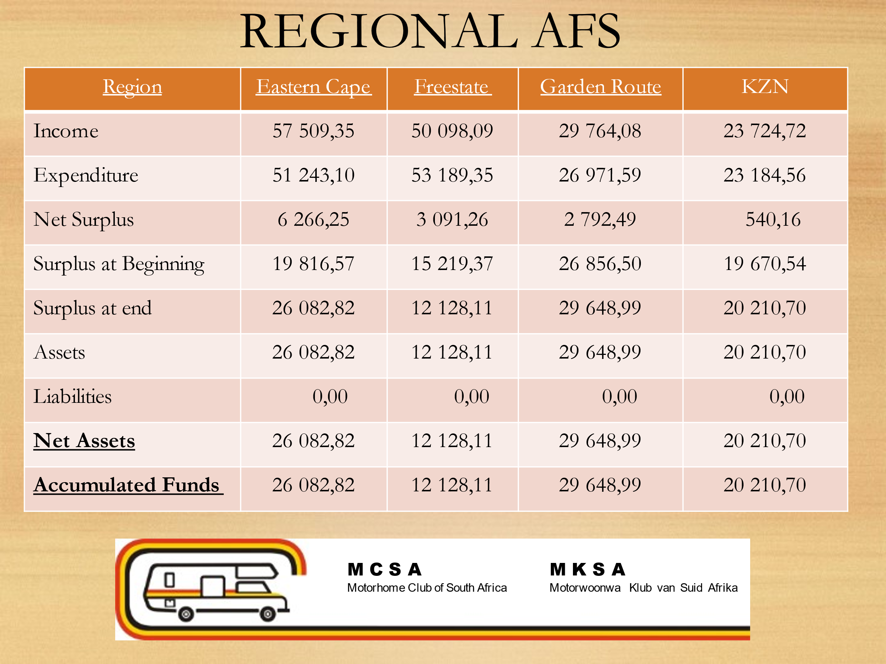

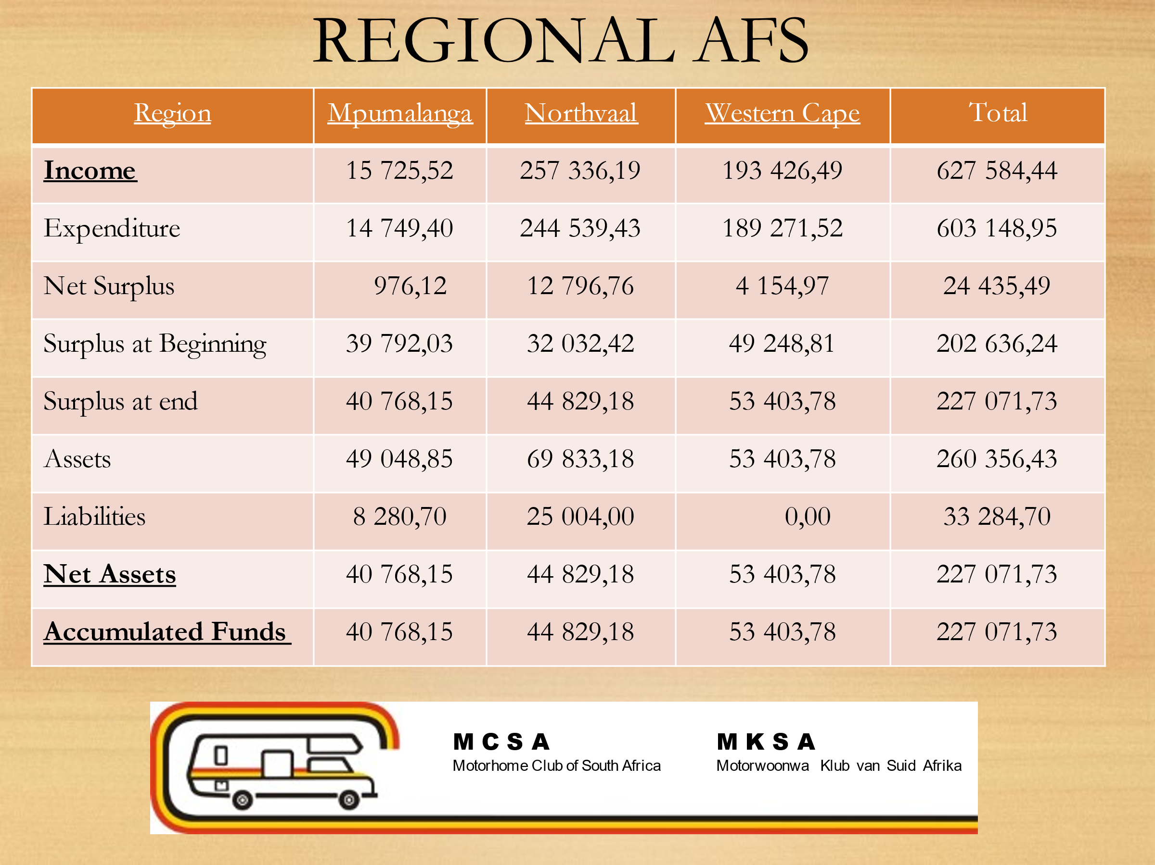

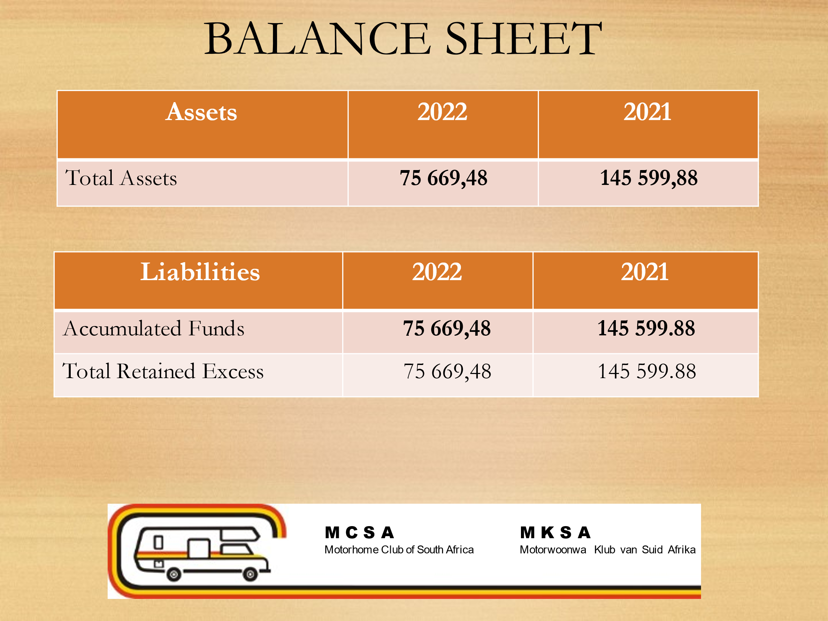

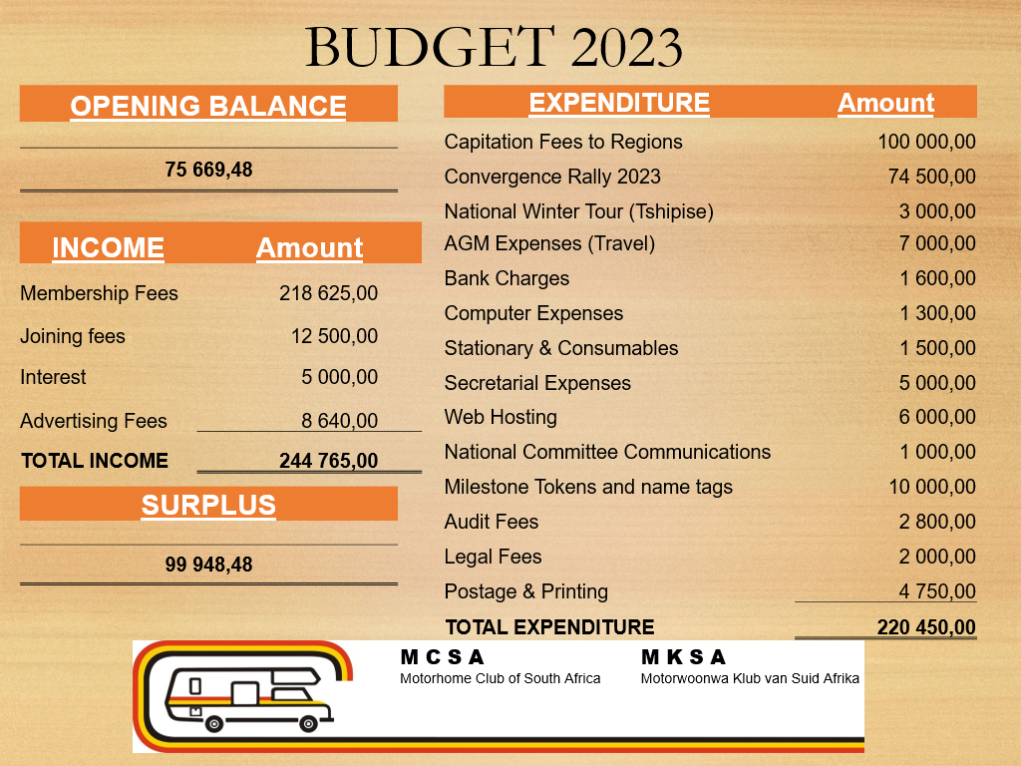
Tim mentioned that he had a look at the budget and an amount of R220 000.00 would be needed for the 40th birthday celebrations in 2024. We have already accrued R180 000.00 but will have to save some more specially to acquire a bigger tent as the last one was too small to accommodate everyone.
No other comments were raised from the floor and the financials were accepted

Approved: Willie van Heusden Seconded: Don Hodginson
- ANY OTHER BUSINESS
8.1. Ratification of Annual subs for 2022/23 (Increase to R 350 pa proposed by Jay
Bezuidenhout

Point placed on the agenda by Jay Bezuidenhout to increase the annual membership fees from R275.00 to R350.00 were discussed. Jay was requested to motivate his suggestion, and he mentioned that although this is a 27% increase in membership fees, that MCSA membership fees are still by far a lot lower than any other social club as he did some research. It was also suggested that this increase might be used for the next point on the agenda which is the honorarium of the club secretary and treasurer. Tim said that MCSA did not have any facilities to upkeep as MCSA does not have a clubhouse etc. to upkeep and that the club is financially strong and does not need an increase. This suggestion was unanimously rejected by all members present. There were two suggestions to increase the membership fees to R300.00 but it was decided that all chairmen will take this suggestion back to their members for discussion to get a general feeling regarding the increase. This will remain on the agenda for the AGM 2023.
It was also mentioned that the excess monies in all the regions accounts should be used toward the members and not accumulated in the various bank accounts as we are a social club and should not accumulate funds. Marius did mention that quit a bit of funds were already used on the AGM’s.
It was also suggested that most of the members resigning from the club is because of the high membership fees, this could not be confirmed as the current records indicate that members resign because they have sold their motorhomes. So, in conclusion the suggestion of the membership fee increase will be discussed at the next National AGM in 2023.

8.2 PROPOSED CHANGES TO THE CONSTITUTION
CURRENT WORDING IN SECTION 12 – REGIONS IN THE CLUB
(c) Each region shall be controlled and managed by a Regional Committee, comprising a Chairman,
Secretary, Treasurer and at least one additional committee member, to be elected at a Regional
Annual or General Meeting, or an inaugural meeting in the case of a new region.
(d) All Committee Members shall retire from office at each Regional Annual General Meeting, but may
be re-elected should they be proposed and seconded.
TO BE REPLACED WITH THE FOLLOWING WORDING IN SECTION 12 – REGIONS IN THE CLUB
(c) Each region shall be controlled and managed by a Regional Committee, comprising a Chairman, Vice
Chairman, Secretary, Treasurer and at least one additional committee member, to be elected at a
Regional Annual or General Meeting, or an inaugural meeting in the case of a new region.
(d) All Committee Members shall retire from office at each Regional Annual General Meeting, but may
be re-elected should they be proposed and seconded, except that the Chairman shall not hold office
consecutively for more than five (5) years.
HUIDIGE BEWOORDING IN KLOSULE 12 – STREKE IN DIE KLUB
(c) Elke streek sal beheer en bestuur word deur ‘n Streek komitee bestaande uit ‘n Voorsitter, Sekretaris,
Tesourier en ten minste een bykomende lid wat gekies sal word by ‘n Streek Jaarvergadering of
Algemene Vergadering, of by ‘n stigtingsvergadering in die geval van ‘n nuwe streek.
(d) Alle Komiteelede sal afstand doen van hulle ampte by elke Streek Algemene Jaarvergadering, maar
mag herkies word, sou hulle voorgestel en gesekondeer word, behalwe die Voorsitter wat nie langer
as drie (3) opeenvolgende jare in sy pos mag dien nie.
WORD VERVANG MET DIE VOLGENDE BEWOORDING IN KLOSULE 12 – STREKE IN DIE KLUB
(c) Elke streek sal beheer en bestuur word deur ‘n Streek komitee bestaande uit ‘n Voorsitter, Visevoorsitter,
Sekretaris, Tesourier en ten minste een bykomende lid wat gekies sal word by ‘n Streek
Jaarvergadering of Algemene Vergadering, of by ‘n stigtingsvergadering in die geval van ‘n nuwe streek.
(d) Alle Komiteelede sal afstand doen van hulle ampte by elke Streek Algemene Jaarvergadering, maar
mag herkies word, sou hulle voorgestel en gesekondeer word, behalwe die Voorsitter wat nie langer
as vyf (5) opeenvolgende jare in sy pos mag dien nie.

The proposed changes to the constitution was unanimously approved.

8.3. Honorarium for Treasurer and Secretary (Jay Bezuidenhout)
Tim fully supports an Honorarium for the Treasurer and Secretary, it was decided that this will be discussed at the next National Committee meeting.

- ELECTION OF NEW COMMITTEE FOR THE FORTHCOMING YEAR.
The Constitution required the election of a Chairman, Vice Chairman,
Treasurer and Secretary. The Regional Chairpersons were automatically members of the National Committee.

The Chairman called on Louis Friess to officiate over the elections.
The following persons were elected and accepted.
Position Candidate
Chairman Willie van Heusden
Secretary Sonja Otto
Treasurer Marius Kruger
Vice Chairman Ralph Jackson
Additional Member Tim Swanepoel
- APPOINTMENT OF AUDITOR
The current auditor Mr Tony Lund. He is a qualified Chartered Accountant of Lund & Kieck, Registered Auditors & Tax Consultants).
Proposed: Marius Kruger Seconded. Tim Swanepoel

- CONFIRMATION OF THE OFFICIAL ADDRESS
The current official address, has been changed to 710 Esther Street, Garsfontein, Pretoria, 0081

- REPORT BY INSURANCE BROKERS
Due to unforeseen circumstances, Johan, has made apologies for not attending the meeting in person. His presentation was read on his behalf by Tim Swanepoel
Motorhome Insurance Scheme Statistics:
583 policies – an increase of 18 on the previous year.
Total premiums received R3 556 797
Claims submitted during year R1 186 387. Claim Ratio 33%. This is made up as follows:
Content claims 7 – R98 205
Windscreen/glass claims 29 - R141 258
Storm Damage 12 – R244 458
Accident Claims 32 – R702 466

- GENERAL
The new website was demonstrated by Marius and a request that Sandy must be informed of all rallies to update the website accordingly. Tim congratulated Sandy on an excellent website and thanked her in her absence.

- CLOSURE
As there was no further business, the Chairman thanked everyone for their presence and declared the meeting closed.

Chairman……………………………………………………………………………….Date

Secretary………………………………………………………………………………Date

